Eat Right!
USER STORY:
As a healthy food consumer, I want to use my phone to scan the barcode of a food product and see a graphic of all its ingredients. The graphic will rank how healthy the ingredients are for my body, illustrated in categories of red (unhealthy), yellow (neutral), and green (healthy), so that I can make healthy shopping decisions for my family.

PRIMARY GOAL:
During this unstructured (open-ended) interview, the goal is to gain impressions about users’ wants and needs for the design concept of the mobile app under development, Eat Right!, through an exploratory one-on-one interviewing process.

ANALYSIS:
Not surprisingly, every person interviewed had the desire to eat healthier and an interest in this new mobile app, Eat Right!, which would primarily be used while looking for something to eat (and when shopping). Neither of these three individuals actually had a health-related app that could be used to scan the UPC barcodes of their food products; however, one interviewee said her husband used a similar app, and she had been satisfied with the healthier food choices they had recently been making. The consensus was that the interface needed to be easy to use, should include horizontal scrolling (opposed to a tabbed interface), and should include as much health-related information as possible. Everyone preferred the dark theme over the light theme, but I think including an option to use either theme is ideal. The three people I interviewed all used Android phones; however, developing for both Android and Apple iOS would be the best choice I think. The benefits of making a native Android app are outweighed by the benefits of designing for both operating systems, in my opinion. Finally, although none of the participants had accessibility concerns (besides being easy to read), accessibility options such as color-blind mode, magnification, and audio narration should be included.
The main difference in the participants’ outlooks was in the amount of time that they saw themselves using the app, with the 42-year-old mom of two using the app for an hour or two a week (opposed to just a few minutes some days). It should also be noted that having only three individuals to interview does not allow for making well-informed design decisions. A larger sample set would be a better representation of the overall population of potential users and would provide a higher level of confidence in this data.

TARGET AUDIENCE:
Adult male and female primary shoppers in each household are our primary demographic, including single or married individuals (with or without children). This app should also be targeted towards people aged 10 to 17 as a secondary demographic, as children carry some influence over their parents’ shopping decisions. No educational, work-related, or income-based constraints are present in this app design. Participants’ education ranged from middle (junior high) school to a post-secondary educated accountant. Family, movies, gaming, and food were common interests, as well as the desire to be conscientious of the nutritional aspects of the food that they eat, in an effort to be healthier! These individuals are most likely to use Android mobile devices to access this app (at home) for anywhere from a few minutes a day to a couple hours a week. We will target both Android and Apple iOS mobile device users in the design of this app.

PRIMARY PERSONA
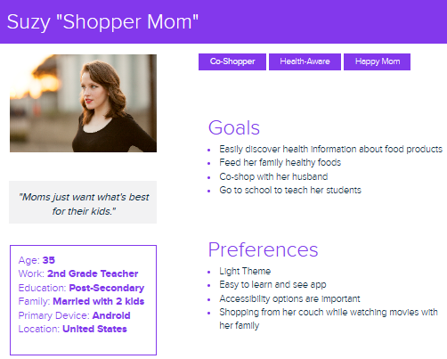
SECONDARY PERSONA
